USB-C to USB3.0A, RJ45, HDMI and USB-C

Overview
This is a USB-C 4-in-1 hub with HDMI, USB-A，RJ45 and Type-C female port, providing an ideal solution for extending the port of Type-C/Thunderbolt 3 host (PC/Laptop/Mobile phone, etc.), especially for those host with a single USB-C port. This hub adopts the latest DP1.4 Alt mode supported IC, enabling to output HDMI video with max 4k/60Hz and at the meanwhile transfer USB 3.1 data with max 5Gbps. RJ45 helps host to get access to super-fast Ethernet network. Besides, the USB-C female supports PD 3.0 with max 100W PD Charging when connecting a PD Adapter and supports max 5Gbps data transmission when connecting a USB-C device. It can work on all DP Alt mode supported Type-C host.

Features
- Operation systems supported: Windows XP/Vista/Win 7/8/8.1/10/Mac OS 10.5 or later
- Thunderbolt 3 Compatible
- Power delivery at up to 100W
- HDMI Resolution up to 4k60Hz
- Network speeds at up to 1 Gbit/s

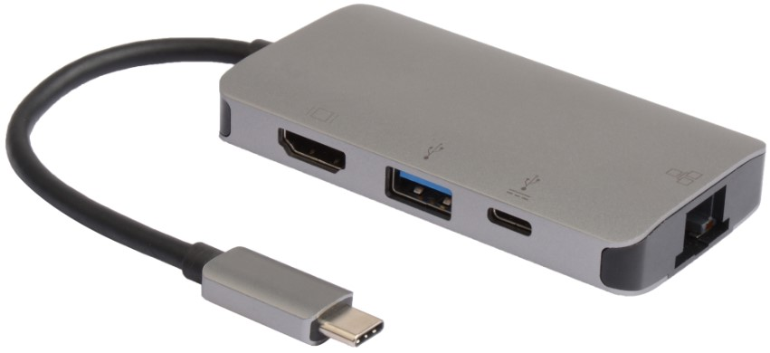

Technical Specification
Model | USB3.1CCOM16 | Specs | Internet speed up to 1 Gbit/s  HDMI supports up to 4096x2160 60Hz 4:4:4 Support 60Hz HDR and HDCP 2.2 support
Length | 0,15m
Material | PVC Cable
Shielding | Single shielded | Warranty | 30 Years
Common applications | For signal between computer / notebook and monitor. | Version | HDMI Version 2.0, PD version 3.0
 | Used to expand the available ports on your notebook/laptop
 |  | Testing | Tested before shipment
Colors | Black | Packing | Microconnect Polybag
 |  | Certifications | CE, FCC
 |  | Installation and use | Plug and Play
 |  |  | Indoor

